**\*\*\*\*\*\*\*\*\*\*\*\*\*\*TestNG notes\*\*\*\*\*\*\*\*\*\*\*\*\*\***

**\*\*\*\*\*Why Use TestNG with Selenium?\*\*\*\*\***

Default Selenium tests do not generate a proper format for the test results. Using TestNG in Selenium, we can generate test results.

Most Selenium users use this more than[Junit](https://www.guru99.com/junit-tutorial.html)because of its advantages. There are so many features of TestNG, but we will only focus on the most important ones that we can use in Selenium. Following are the key features of Selenium TestNG:

* Generate the report in a proper format including a number of test cases runs, the number of test cases passed, the number of test cases failed, and the number of test cases skipped.
* Multiple test cases can be grouped more easily by converting them into testng.xml file. In which you can make priorities which test case should be executed first.
* The same test case can be executed multiple times without loops just by using keyword called 'invocation count.'
* Using testng, you can execute multiple test cases on multiple browsers, i.e., cross [browser testing](https://www.guru99.com/top-10-cross-browser-testing-tools.html).
* The TestNG framework can be easily integrated with tools like TestNG Maven, Jenkins, etc.
* Annotations used in the testing are very easy to understand ex: @BeforeMethod, @AfterMethod, @BeforeTest, @AfterTest
* WebDriver has no native mechanism for generating reports. TestNG can generate the report in a readable format like the one shown below.

[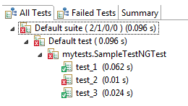](https://www.guru99.com/images/report-0057.png)

## ***********Checking reports created by TestNG:-*************

The Console window in Eclipse gives a text-based report of our test case results while the TestNG Results window gives us a graphical one.

[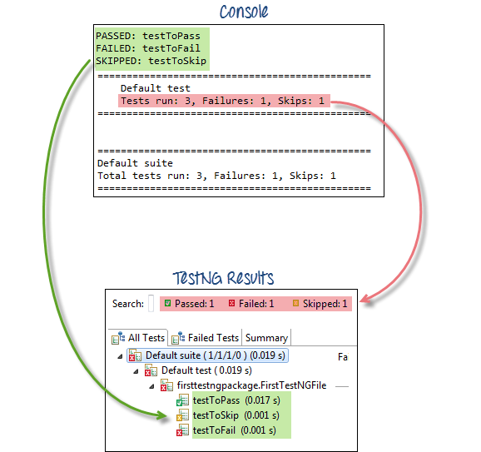](https://www.guru99.com/images/text_vs_graphical-0016.png)